**How to launch PowerShell**

**Step 1)** Search for PowerShell in Windows. Select and Click

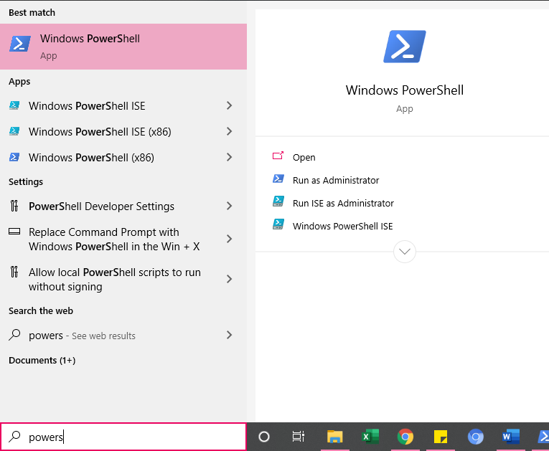

**Step 2)** Power Shell Window Opens

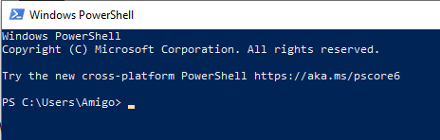

**Get-Help:** Help about PowerShell commands and topics

Example: Display help information about the command Format-Table

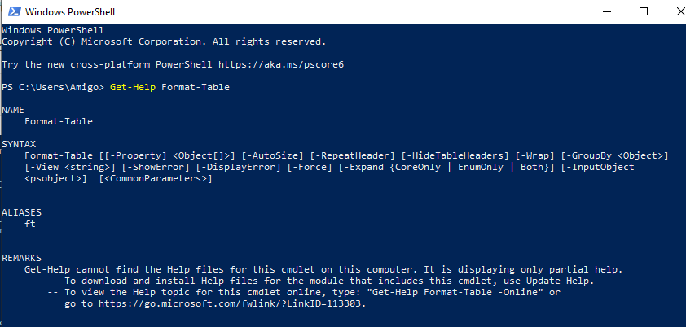

**Get-Command:** Get information about anything that can be invoked

Example: To generate a list of cmdlets, functions installed in your machine

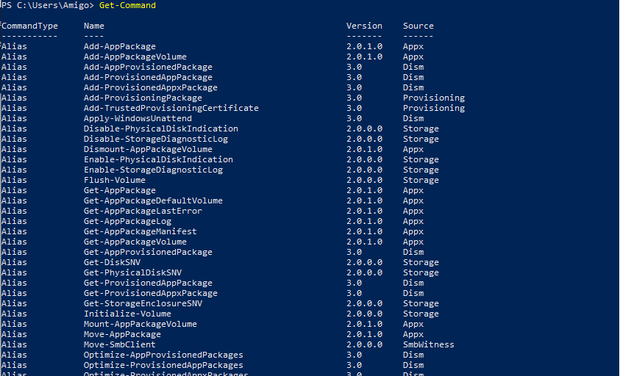

**Get-Service:** Finds all cmdlets with the word 'service' in it.

Example: Get all services that begin with "vm"

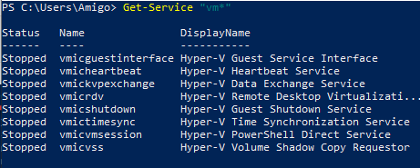

**Get- Member:** Show what can be done with an object

Example: Get members of the vm processes.

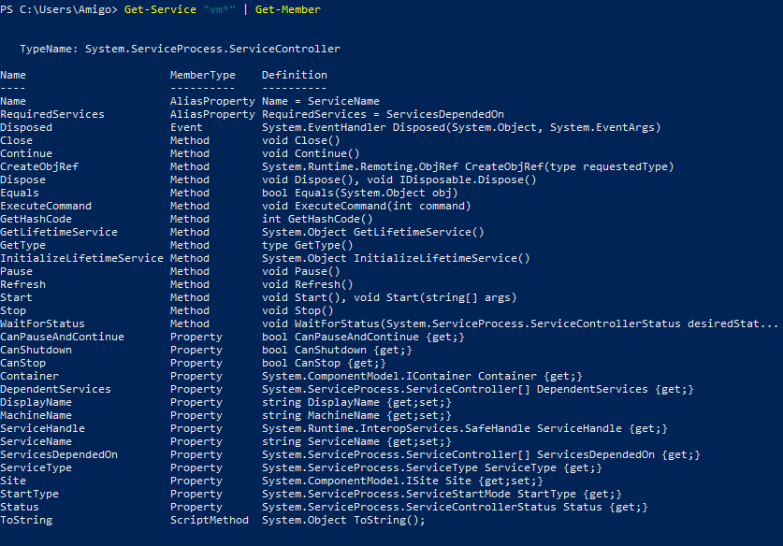

Example: Create a Folder

New-Item -Path 'D:Bootcamp\Guru99' -ItemType Directory

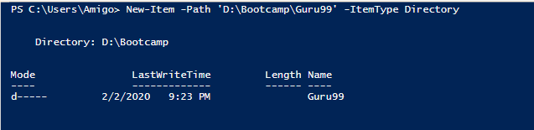

## PowerShell Scripts

Step 1: right-click it and click "Run with PowerShell."

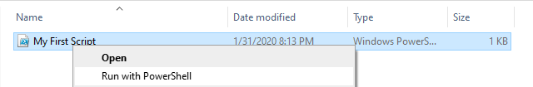

Steps to Change Execution Policy

**Step 1)** Open an elevated PowerShell prompt. Right Click on PowerShell and "Run as Administrator"

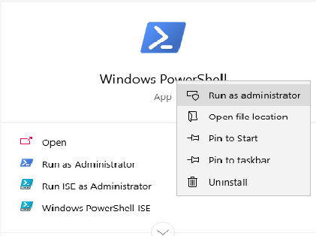

**Step 2)** Enter the Following commands

1. Get-ExecutionPolicy
2. Set-execution policy unrestricted
3. Enter Y in the prompt
4. Get-ExecutionPolicy

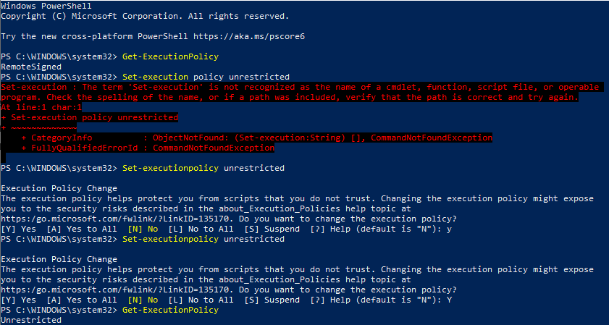

### First PowerShell Script

In a notepad write the following command

Write-Host "Hello, World!"

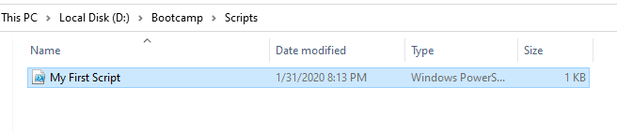

In Powershell, call the script using the command

& "X:\FirstScript.ps1"

